Screenshots of Outputs
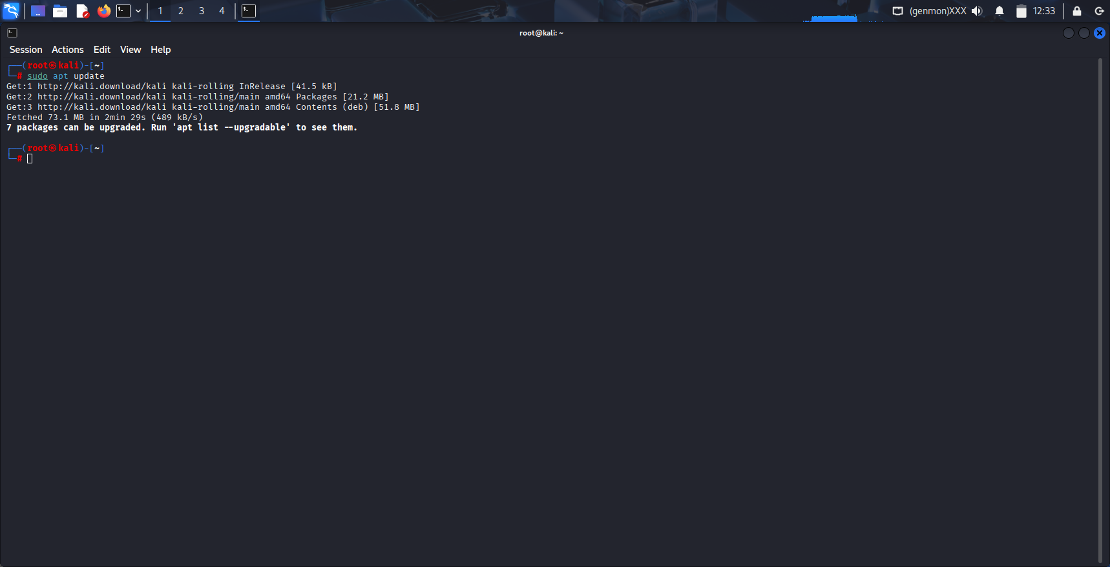
Fig. 1: Executing apt update on Kali Linux

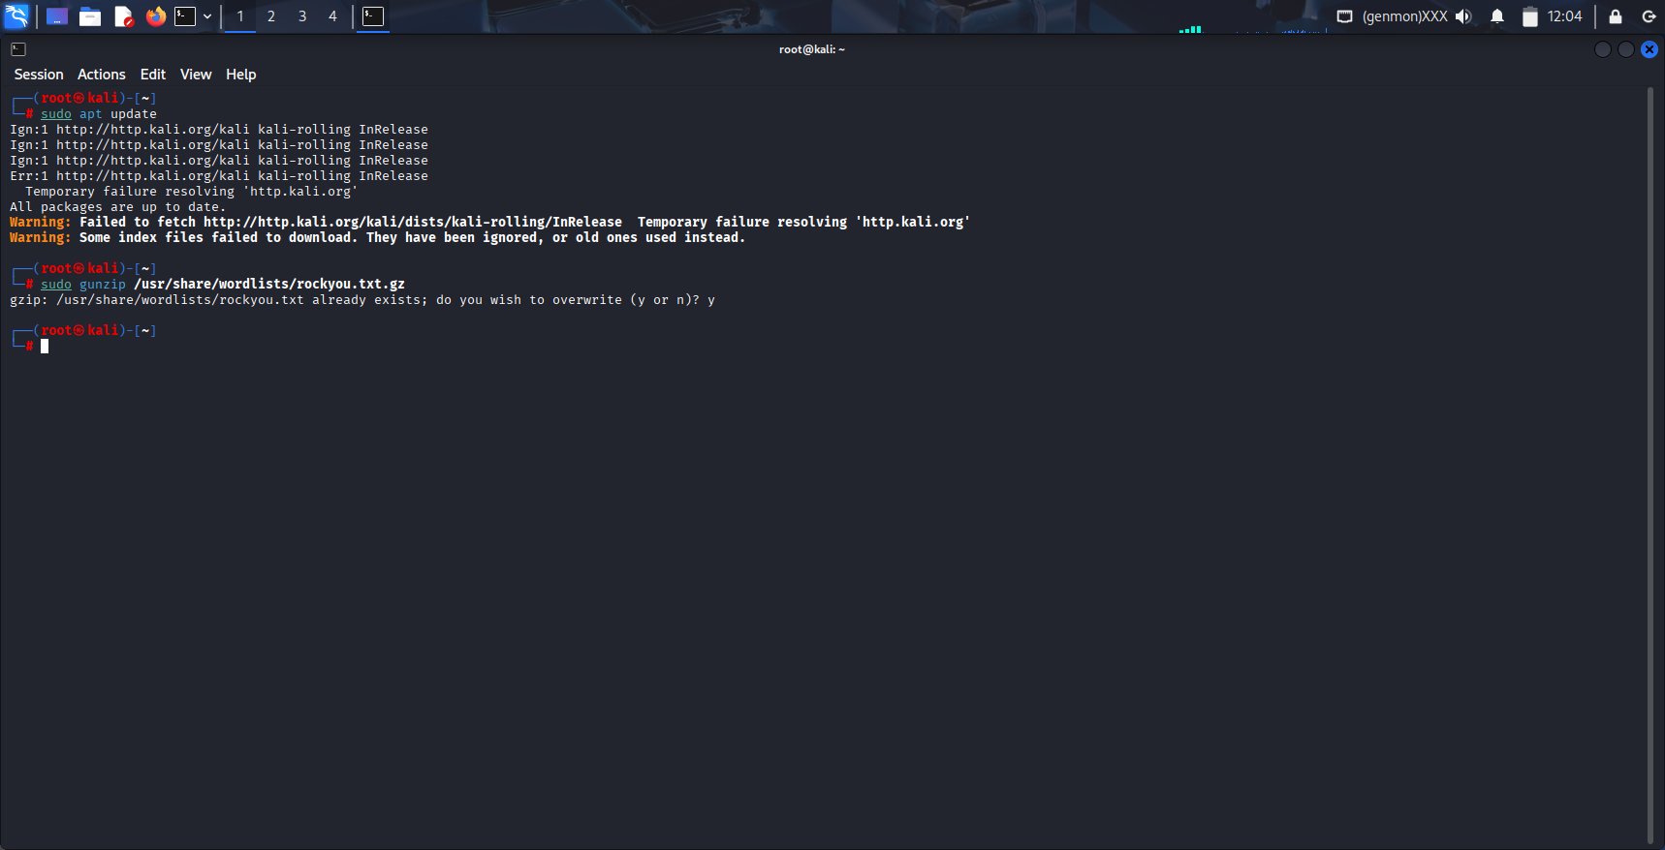
Fig. 2: sudo gunzip /usr/share/wordlists/rockyou.txt.gz to decompress the file

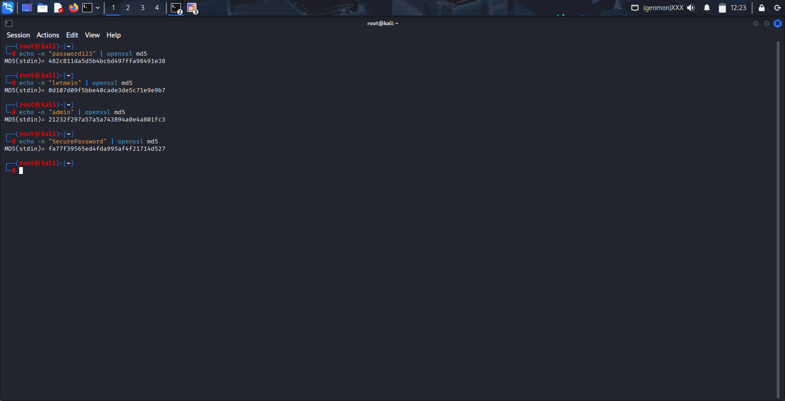
Fig. 3: MD5 hashes are generated using above commands

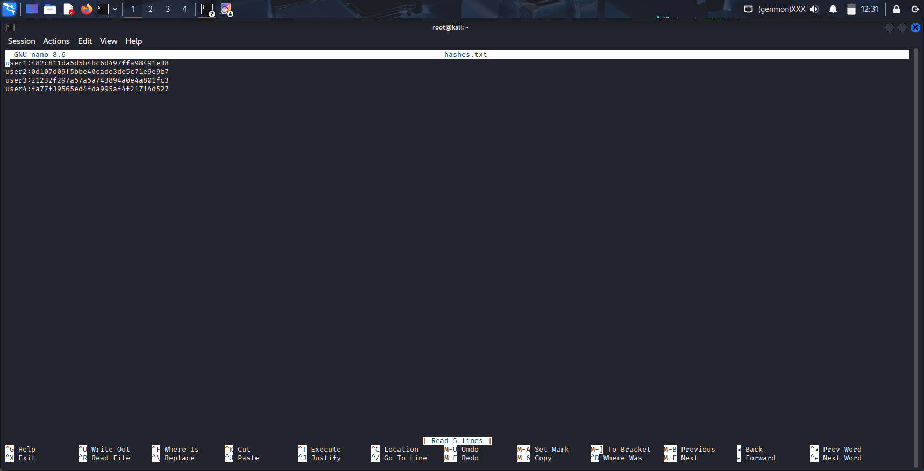
Fig. 4: Entering the hash values in hashes.txt file

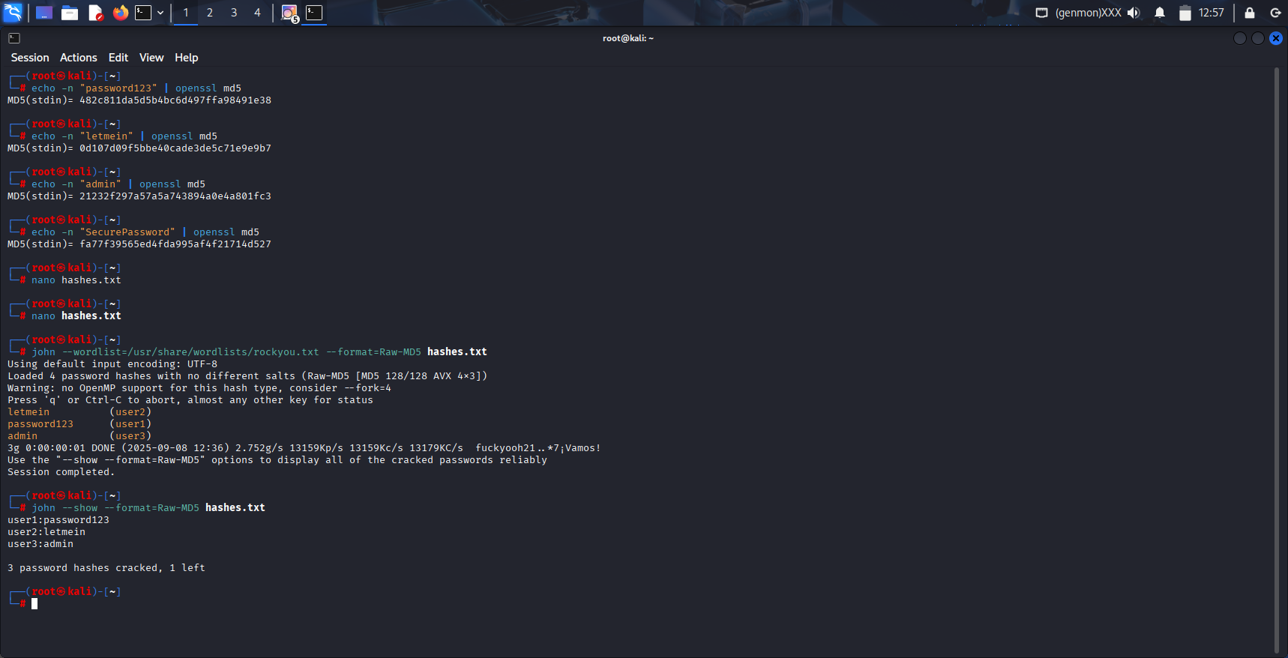
Fig. 5: Executing dictionary attack


Fig. 6: Finall results by using john --show --format=Raw-MD5 hashes.txt

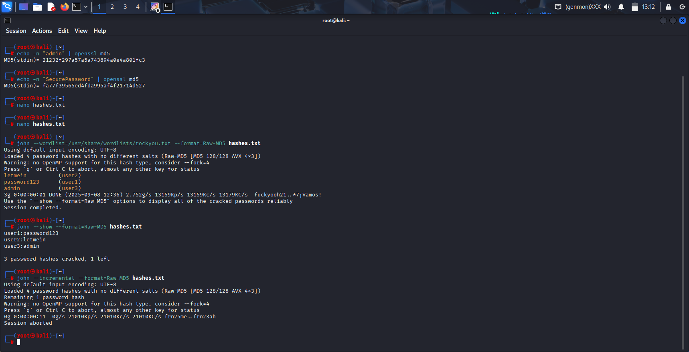
Fig. 7: password_cracking_workflow

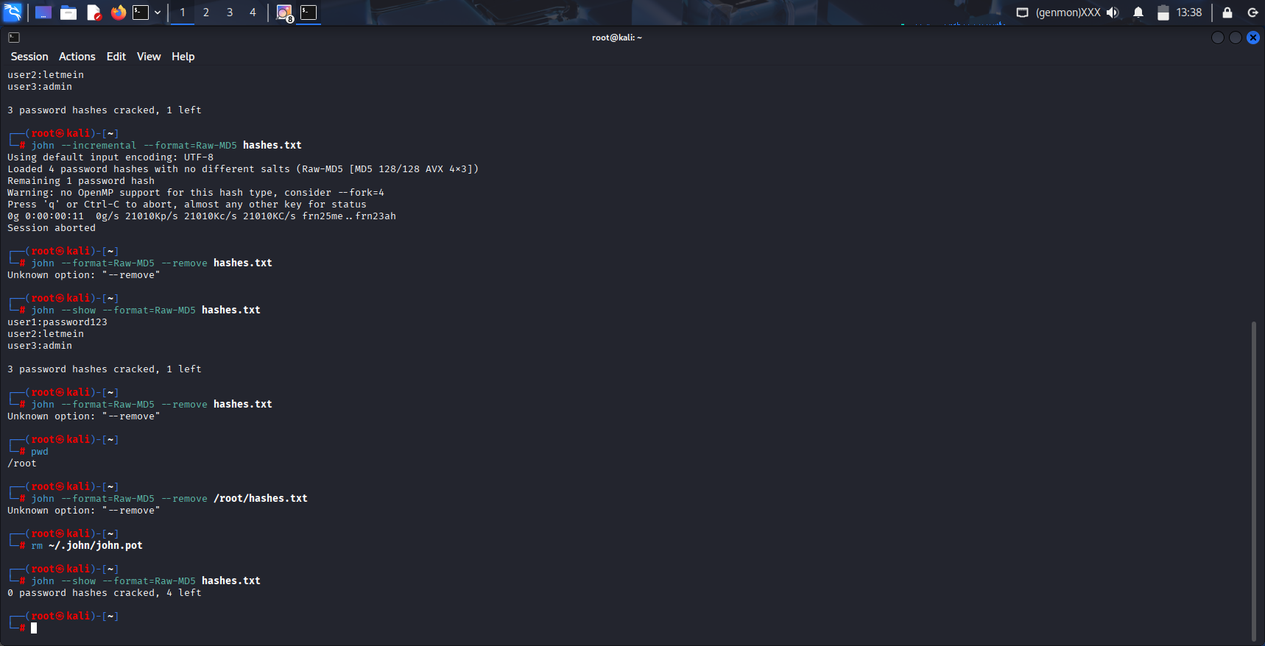
Fig. 8: wipes John's entire history of cracked passwords for all files

